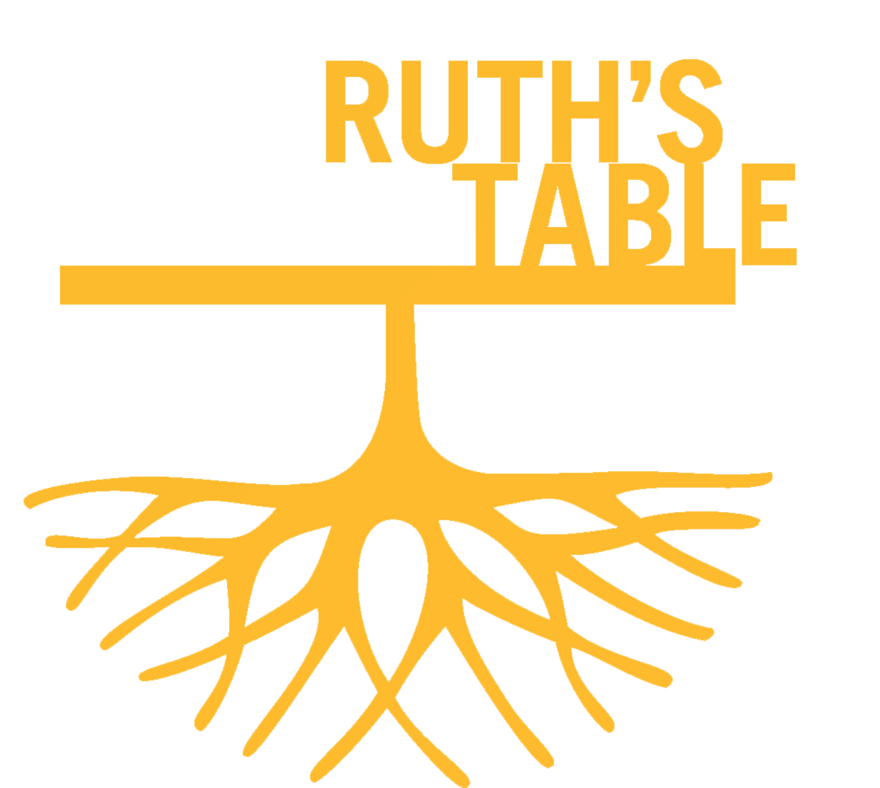
The Art of Disability Culture:
Artists with Disabilities Dispelling Myths,
Dissolving Barriers, and Disrupting Prejudice
The Art of Disability Culture at Ruth’s Table is an invitation to engage with the work of disabled artists and expand our understanding of the disability community. The exhibition is
a continuation of one hosted by the Palo Alto Art Center in
the fall of 2021 and aims to keep the conversation going. Ruth’s Table is a valued ally in the work of inclusion and participation for people with disabilities, and a perfect venue
to showcase organizations that continue to pioneer inclusive art practices and artists whose work will challenge us.

One in four people have a disability or will acquire one through age, and although we have the Americans with Disabilities Act (ADA) and other legal protections, discrimination, prejudice, and exclusion persist. Indeed, many disabled artists have become activists as a response to an often hostile or inaccessible world. The Bay Area is a fertile home to many organizations and activists who continue to forward disability rights and disability justice and disabled artists are an integral part of this strong and expanding ecosystem. Their practice and their work provide us all with
a valuable model of communication and support that relies
on interdependence, patience, and ingenuity.

The exhibition aims to create a safe space of reflection and contemplation, one in which it is fine to stare and experience the humanity of others. We hope that you spend time with the artwork here and leave with a new perspective and insight into the local disability community and the power of disability culture to make our society stronger and more resilient.

Fran Osborne
Guest Curator
Acknowledgments
Grateful thanks to all the artists, private lenders, Walter Maciel Gallery in Los Angeles, Creative Growth, NIAD, and Creativity Explored for making this exhibition possible.

Artists:
​​Bill Bruckner, Jeremy Burleson, Shana Harper, Camille Holvoet, Antoine Hunter,Cedric Johnson, Kaocrew ‘Yah’ Kakabutra, Michaela Oteri, Maria Radilla, Katherine
Sherwood, Anthony Tusler, Rachel Ungerer.

Bill Bruckner

Self Portrait, 2011
Acrylic on canvas

Leroy #2, 1997
Acrylic on canvas

Jan, 2001
Acrylic on canvas

Yvette, 1993
Acrylic on canvas

Courtesy of the artist

“These paintings are part of an ongoing series of portraits of friends who have disabilities that I began in the early 1990s. One of my intentions is to create images that convey disabled people’s ordinary―not heroic―dignity, humanity, and self-respect. In most of these works, I have attempted to present the persons you are viewing as looking directly back at you, as curious about you as you may be about them.” – Bill Bruckner

Bill Bruckner made many self-portraits before he felt ready to paint his disabled friends and colleagues. He wanted to be completely accepting of his own physical reality before asking others to sit for him. In this self-portrait he faces us with a clear and steadfast gaze, bare-chested, with his naked torso on open display. The portraits encourage us to engage, to hold the sitter’s gaze and linger on the details. The portrait of disability activist and scholar, Leroy J. Moore Jr., has graced many book-covers and flyers since 1993.

Bill Bruckner lives in San Francisco. His work has been exhibited in solo and group exhibitions in San Francisco, New York, Chicago, Philadelphia, Washington D.C., and Miami.

https://billbrucknerartist.com/

Jeremy Burleson (NIAD)

Untitled
Rolled paper, marker, tape

Untitled
Rolled paper, marker, tape

Untitled
Rolled paper, marker, zip-ties

Courtesy of NIAD Art Center

Jeremy Burleson is known for his sculptures from simple everyday materials as well as energetic line drawings of figures, bottles, syringes, balloons and cacti.
His sculptures sometimes evoke medical instruments like stethoscopes, or tubes and monitoring equipment.

Burleson’s work has been collected and exhibited for over a decade and several of his works were included in the traveling exhibition Create co-curated by Larry Rinder and Matthew Higgs, organized by the Berkeley Art Museum in 2011.

https://niadart.org/jeremy-burleson/

Shana Harper (NIAD)

Being Normal is Overated, 2017
Printer’s Ink in Stretched Canvas

Being An Artist is The Best Feeling in The World, 2017
Letterpress Print

Courtesy of NIAD Art Center

“When I work in the studio, I like to stay in one spot so
I can focus. I like to repeat an image; that’s why stencils and printmaking interest me ... Learning printmaking was a challenge over the last decade. I want my art to expand into the world … I want you to know that being an artist
is the best feeling in the world.” ― Shana Harper
Shana Harper often works with text and pattern.
She experiments widely and her text prints often subvert the messages of those warm, homely signs we often see in décor stores. Her wit and sarcasm send out a strong, anti-ableist message emphasizing that people with developmental disabilities still face discrimination and have much to say that is valuable.

Harper has been making art at NIAD for over 10 years. Her work recently featured in The Art of Resilience: Black Artists Surviving and Thriving in The Bay Area at the ACCI Gallery in Berkeley 2020.
https://niadart.org/shana-harper/

Camille Holvoet (Creativity Explored)

Medication, 2020
Pen and colored marker on paper

Anti, 2020
Pen and colored marker on paper

Medication, 2020
Mixed media on paper

Courtesy of Creativity Explored

Over her career, Camille Holvoet has developed a very keen local fan base for her distinctive and highly colorful artworks. The descriptive text in many of her pieces
is often confessional and complicates the apparent sweetness of her color palette and images. She will often focus on the many temptations of life: all kinds of sumptuous cake, and the Ferris wheel are common motifs in her work. Many of her works also convey her ongoing relationship with medication and its function in her life.

Camille Holvoet was born in San Francisco in 1952 and has been an artist at Creativity Explored since 2001.

https://www.creativityexplored.org/artists/camille-holvoet/

Kaocrew “Yah” Kakabutra (Creativity Explored)

Untitled, 2020
Mixed media, textiles and embroidery

Courtesy of Creativity Explored

Kaocrew “Yah” Kakabutra joined the Creativity Explored studio in 2011 after moving from Thailand to the US in 1997. Kakabutra communicates through her artworks and her loving, kind, and sociable personality.
Initially making small-scale works on paper, her mark making is as diverse as the media with which she uses.
Her willingness to experiment has led Kakabutra to projects that would overwhelm a less confident artist.
An experimentalist by nature, Kakabutra’s practice has literally expanded to massive color-rich canvases with varying types of marks created by applying paint with sticks, whips, and brushes of many sizes.
www.creativityexplored.org/artists/kaocrew-yah-kakabutra

Antoine Hunter

The Silence: American Sign Language Dance, 2020
Video (5:41 on repeat)

Courtesy of the artist

“I know for hearing people, my words remain silent, as if
I come from another world. But through my dance, I think people can better understand my silent world. At the end, I want the audience to join together in signing, to signal we are all one spirit. I hope people leave feeling that we can all coexist and be part of each other’s lives in some meaningful way.” ―Antoine Hunter

Celebrated Bay Area Deaf dancer Antoine Hunter collaborated with acclaimed theater director Ellen Sebastian Chang on the creation of Silence, a dance broken into three parts. His choreography incorporates movements from American Sign Language (ASL), jazz, and modern and classical American dance.

Against an urgent and rhythmic score of cello and violin, Hunter begins with raised arms under a single spotlight,
in a gesture of calling in. He takes us on a deeply personal journey into the intensity of his experience.
His movements throughout invite us to consider ASL as
a form of dance, and dance as a non-verbal and gestural language.

Antoine Hunter/Purple Fire Crow is as an African, Indigenous, Deaf, Disabled, Two Spirit producer, choreographer, film/theater actor, dancer, dance instructor, model, poet, speaker, mentor, and Deaf advocate. He lives and works in Oakland. and amongst many other accomplishments runs the annual Bay Area Deaf Dance Festival and curated the Bay Area Deaf Arts exhibition at SOMArts in San Francisco in 2020.

https://www.realurbanjazzdance.com/mr-antoine-hunter.html

Cedric Johnson (Creative Growth)

Untitled, 2019
Glazed Ceramic

Untitled, 2019
Glazed ceramic

Courtesy of the Artist and Creative Growth

“Straight up from my imagination.” – Cedric Johnson

Cedric Johnson always knew he wanted to be an artist. He works with a wide range of media, from wood and textiles to ceramics and printmaking. He combines vibrant color palettes with intricate linear patterns and often creates ceramic masks or uses masks as a favorite symbol in his works on paper.

Johnson was born in Corpus Christi, Texas in 1952 and has been creating a wide variety of two- and three-dimensional art at Creative Growth since 1980. He has exhibited in group shows at Creative Growth, Rena Bransten Gallery and Gallery Paule Anglim in San Francisco. His first solo exhibition featuring 20 of his artworks, including 6 ceramic pieces was in 2016, at Ampersand in Portland, Oregon. Johnson’s work has also featured in designs for limited edition chocolate bar packaging for Guittard.
https://creativegrowth.org/cedric-johnson/
Michaela Oteri

Self-portrait, 2020
Digital Print

Memorial Portrait of Stacey Park Milbern, May 23, 2020
Digital Print

Courtesy of the artist

“My passion is for depicting diverse people of all kinds, especially in my Disabled Beauty Series which showcases Disabled People for Disabled People.”

Michaela Oteri’s graphic works portray the diversity and dignity of disabled people from all backgrounds. Her graceful forms and glorious use of color evoke the balance and sinewy forms of art nouveau, especially the lithographs by Czech artist Alphonse Mucha. Oteri’s carefully composed digital designs use colors and motifs that are meaningful to the sitter. If visible, the sitter’s disabilities are neither hidden nor disguised.

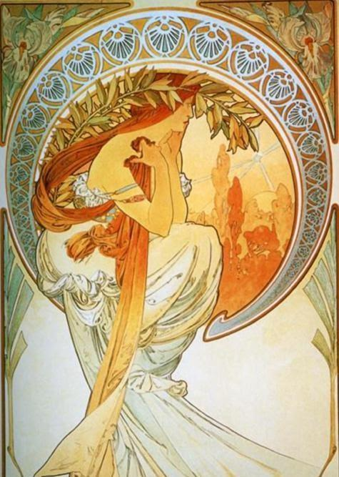
Alphonse Mucha, Poetry, 1898, ithograph.
Creative Commons
https://commons.wikimedia.org/wiki/File:Alphonse_Mucha_-_Poetry.jpg
Oteri’s self-portrait hints at the disability future movement, which pushes for a new reality of improved access and inclusion. At the same time, the work reminds us that disabled people are here to stay and have much
to contribute.

The memorial portrait of activist Stacey Park Milbern was created almost as soon as the sad news of her passing spread. Milbern touched many lives and founded the Disability Justice Culture Club in Oakland. She left
an important legacy for young people with disabilities and Oteri’s portrait aims to honor her love of community and her joy.
“I would want people with disabilities 20 years from now
to not think that they're broken. You know, not think that there's anything spiritually or physically or emotionally wrong with them, you know, and not just people with disabilities, but queer people and gender nonconforming folks and people of color …” – Stacey Park Milbern

Oteri is self-taught and lives in Florida but has strong ties to the Bay Area disability community. She is currently working on a range of portraits of disabled children in collaboration with Alice Wong from the Disability Visibility Project.

https://www.ogrefairy.com/

Maria Radilla (NIAD)

Pajarito, 2020
Acrylic on mixed media sculpture

Pajarito, 2020
Acrylic on mixed media sculpture

Pajarito, 2020
Acrylic on mixed media sculpture

Courtesy of the NIAD Art Center
I’m inspired by my childhood in Mexico, fashion, food, flowers, and traditions where we give and receive gifts. These are the things that I really love.
When I make artwork with fabrics, I think about my experiences: growing up, I had dolls and played with them in fields of flowers by my home. I love flowers that are red or yellow or white. I also look at a lot of books, especially a big book of colorful birds and a catalogue filled with pictures of beautiful old dolls. I go through the images and pick a different doll to embroider onto a quilt or make into my own doll. I’ve also made dolls based on figures in paintings, like the people in Goya’s paintings of the Spanish courts. I love when people have my art in their homes. I love how people love everything I make.” — Maria Radilla
https://niadart.org/maria-radilla/

Katherine Sherwood

After Ingres, 2014
Acrylic and mixed media on recycled linen
(From the Venuses of the Yelling Clinic Series)
Courtesy of the Artist & Walter Maciel Gallery,
Los Angeles, CA

“At around 25 years of age I started realizing that making art made me exceedingly happy. That’s been the case ever since ... I was so happy to merely change hands after I had the stroke instead of giving up my avocation.” — Katherine Sherwood

Katherine Sherwood found a new way of working after
a serious stroke in the Spring of 1977 at the age of 44.
By switching to her left hand during her recovery, she continued to paint but now with ready-mixed pigment and using larger canvases that were easier to handle.

“I think when you experience something so absolutely life altering as a cerebral hemorrhage you see that, “okay,
I wasn’t in control.” And what’s happening is not just the conscious person inside of me. Once you give up any notion of control then I think life goes a lot easier. That’s what I’ve experienced.”

Here, we show three pieces from her large body of work. Two are from a series called The Healers of the Yelling Clinic and one from the Venuses of the Yelling Clinic. Sherwood founded The Yelling Clinic with Sunaura Taylor at UC Berkeley as a collective of artists with disabilities who aim to spread awareness on disability and art therapy, with a focus on the intersections between war and disability. Ceramicist Ehren Tool and artist Chau Thuy Huynh are also members.

Sherwood playfully challenges us to consider our role and our bias by subverting many established art historical conventions, and weaves in questions of staring and looking. In the Healers series she frequently uses imagery from medical brain illustrations by Santiago Ramon y Cajal, who won the Nobel prize in 1906 and always wanted to be an artist but was pushed into medicine by his father. In the Venus series we are prompted to notice our role as onlookers. As we stare at, and judge
the female (and the disabled) body, are we seeing through the “male gaze” or valuing difference and fragility?

After Ingres is based on the painting Grande Odalisque by Dominique Ingres dating from 1814. The original Ingres painting caused uproar in the salons of France and there were jokes about the impossible length of the subject’s back, having “two or three vertebrae too many” because of the artificial elongation of her spine. Scholars have subsequently found that Ingres deliberately distorted
the model’s proportions and shortened her left arm.

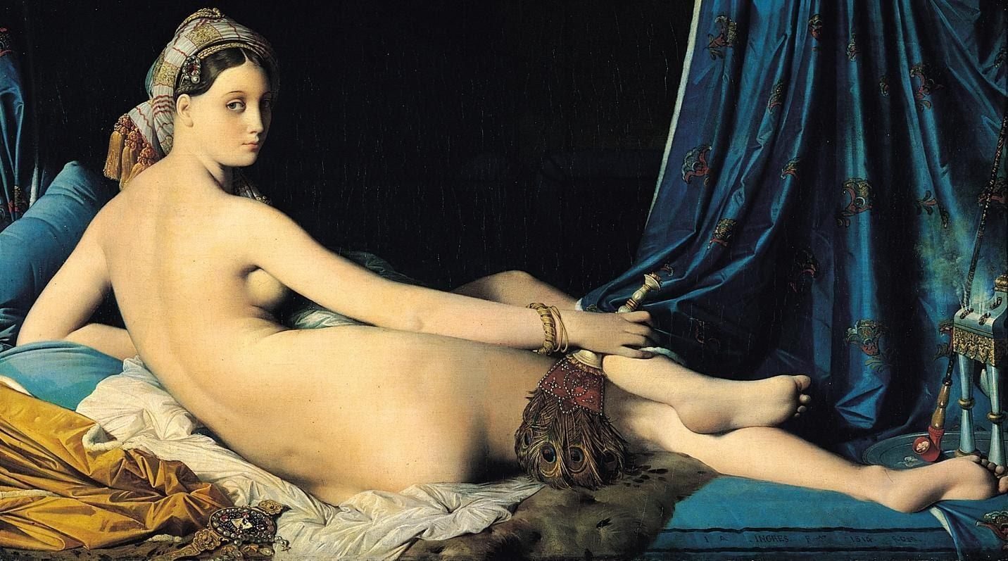
Dominique Ingres, Grand Odalisque, 1814, oil on canvas. Creative Commons
https://commons.wikimedia.org/wiki/Category:La_Grande_Odalisque

Katherine Sherwood was born in New Orleans, LA, and educated at UC Davis and the San Francisco Art Institute. Her work is collected by major institutions, and she exhibited at the Whitney Biennial in 2000.
Sherwood was a Professor of Art History and Art Practice at the University of California, Berkeley for 30 years and was awarded an honorary doctorate from the School of the Art Institute of Chicago in 2020.
In 2021 she joined the board of Creative Growth.
https://www.katherinesherwood.com/

Anthony Tusler

AXIS Dance, 2017
Digital print

Gaelynn Lea, 2019
Digital print

Maxi-Selfie, 2016
Digital print

Gimmee the Mic, 2017
Digital print

It Will Happen, 1977
Digital print (original 35 mm negative)

We Shall Overcome, 1977
Digital print (original 35 mm negative)

Sign 504, 1977
Digital print (original 35 mm negative)

Jim Gonzalves and Hale Zukas, 1977
Digital print (original 35 mm negative)

Courtesy of the artist

“I am a Disabled person. The world designates me disabled because I use a power wheelchair. Both
the positive and negative aspects of that category have
a powerful influence on how I see myself. My goal is to value and celebrate my membership in the disability community and my disability identity; while recognizing
the prejudice I encounter and the day-to-day travails of being human and disabled.”

Anthony Tusler’s iconic black-and-white photos from
the disability rights movement are often used in disability history projects. The 1977 occupation of the federal building by more than 100 people with disabilities for
26 days helped bring in the regulations for Section 504
of the Rehabilitation Act, the first civil rights legislation
for disabled people. Back then, Tusler was just beginning
to discover the importance of activism and the fight for disability rights. He began documenting the daily life of friends and colleagues as the Bay Area’s Independent Living Movement was taking shape.

The large “bad-boy” portrait reveals a newly developing disability identity and confidence, as the artist leans forward to stare at us, provoking us to take in his intensity, his braces, his wheelchair, and his sneer. From the beginning, Tusler’s generation of activists and artists refused to be defined by others, asserting their own unique identity.

Around the 2010s and the rise of digital photography, Tusler began to shoot the community again, with enthusiasm and this time in color. His contemporary photographs reveal some of the important changes between the 1970s and now, but also indicate how much work there is still to do. By shooting from his power chair Tusler gives us a lower vantage point than we may be used to, and his tender portraits of cultural gatherings and everyday connections, bring us into the heart of the local disability arts experience.

Anthony lives in Penngrove California and has helped launch several non-profits, including the Institute on Alcohol, Drugs, and Disability, Community Resources for Independence, Disability Associates, and the National Center on Disability and Journalism. His photographs have featured in the Oscar-nominated 2020 film “Crip Camp” and have been shown at the National Center for Civil and Human Rights, Atlanta, and SOMArts, and
the de Young Museum in San Francisco.

https://aboutdisability.com/

Rachel Ungerer

Disabled Strong, 2020
Charcoal drawing on paper

Will I Lose My Dignity, Invisible in Your World? 2021
Acrylic paint on repurposed jeans

They is loved: Pleasure in Pain, 2020
Acrylic paint on repurposed jeans

Courtesy of the artist

“This work explores how vulnerability can be an asset
in relationships, rather than a weakness as society suggests. The vulnerability of disabled people and our varying levels of dependency are infantilized in our ableist society… One of the biggest challenges of having
an invisible disability is being gaslit and thus not receiving reasonable care. Regularly we will be bullied off the bus seat or denied accommodations for employment.

By publicly identifying as someone with an invisible disability, Rachel Ungerer hopes to promote greater awareness and eliminate the negative stigmas.

In these dense narrative paintings, her focus is on personal relationships and lived experience. In these works, viewers witness everyday moments that may be unfamiliar to non-disabled people but are all too common for people with disabilities. We are shown the exhaustion of one’s needs being discounted by a hostile and complacent public, but we are also shown the power
of interdependence and love.

Ungerer’s lush use of paint and simple color palette reinforces the intensity of her pieces. Her snapshot paintings of chosen moments encourage us to rethink what we know about the disability community and our own prejudice and bias. Her work was created while in chronic pain and with limited use of her hands.

Rachel Ungerer lives and works in Oakland and has
a BA in Fine Arts from the University of California, Los Angeles with a focus on painting. Her work has been shown in Los Angeles, Louisville KY, and San Francisco.

https://www.rachelungerer.com/

